8th Grade
Math Aligned
Sample Items

Created for Morehouse Parish School System by Dr. Stacey Pullen

8th Grade
Sample Math Items Aligned to CCSS
Table of Contents

CCSS Code | Page # | CCSS Code | Page #
8.NS.A.1 | 3 | 8.G.C.9 | 44
8.NS.A.2 | 4 | 8.SP.A.1 | 46
8.EE.A.1 | 5 | 8.SP.A.2 | 48
8.EE.A.2 | 6 | 8.SP.A.3 | 50
8.EE.A.3 | 7 | 8.SP.A.4 | 52
8.EE.A.4 | 8 | Key | 54
8.EE.B.5 | 9 | Rubrics | 56
8.EE.B.6 | 11 | Origination of Items | 62
8.EE.C.7 | 12
8.EE.C.7a | 13
8.EE.C.7b | 14
8.EE.C.8 | 15
8.EE.C.8a | 16
8.EE.C.8b | 17
8.EE.C.8c | 18
8.F.A.1 | 20
8.F.A.2 | 23
8.F.A.3 | 25
8.F.B.4 | 26
8.F.B.5 | 27
8.G.A.1 | 28
8.G.A.1a | 29
8.G.A.1b | 30
8.G.A.1c | 31
8.G.A.2 | 32
8.G.A.3 | 35
8.G.A.4 | 36
8.G.A.5 | 38
8.G.B.6 | 40
8.G.B.7 | 41
8.G.B.8 | 43
8th Grade
Sample Math Items Aligned to CCSS
8.NS.A.1
Know that numbers that are not rational are called irrational. Understand informally that every number has a decimal expansion; for rational numbers show that the decimal expansion repeats eventually, and convert a decimal expansion which repeats eventually into a rational number. (Conceptual Understanding & Procedural Skill and Fluency)

What test questions look like:
Sample 1:
Which decimal is the equivalent of 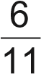 ?

  - 0.183

  - 0.183

  - 0.54
___
  - 0.54

8.NS.A.2
Use rational approximations of irrational numbers to compare the size of irrational numbers, locate them approximately on a number line diagram, and estimate the value of expressions (e.g., π²). For example, by truncating the decimal expansion of √2, show that √2 is between 1 and 2, then between 1.4 and 1.5, and explain how to continue on to get better approximations. (Conceptual Understanding & Procedural Skill and Fluency)

What test questions look like:
Sample 1:
The length of the diagonal of a rectangle is 181 inches.
Which statement describes the length of the diagonal?
    - The length is between 12 and 13 inches.
    - The length is between 13 and 14 inches.
    - The length is between 14 and 15 inches.
    - The length is between 15 and 16 inches.
Sample 2:
Which statement best describes the value of $\sqrt{8}$?
- The value of $\sqrt{8}$is between 2 and 2.5.
- The value of $\sqrt{8}$ is between 2.5 and 3.
- The value of $\sqrt{8}$ is between 3 and 3.5.
- The value of$\sqrt{8}$ is between 3.5 and 4.

8.EE.A.1
Know and apply the properties of integer exponents to generate equivalent numerical expressions. For example, 3² × 3⁻⁵ = 3⁻³ = 1/3³ = 1/27. (Conceptual Understanding & Procedural Skill and Fluency)

What test questions look like:
Sample 1:
Which expressions are equivalent to 3⁴?
Select all that apply.
    - 3² + 3²
    - 3 × 4
    - 3² × 3²
    - (3²)²
    - 4 × 4 × 4
    - (3¹)⁴

8.EE.A.2
Use square root and cube root symbols to represent solutions to equations of the form x² = p and x³ = p, where p is a positive rational number. Evaluate square roots of small perfect squares and cube roots of small perfect cubes. Know that √2 is irrational. (Conceptual Understanding & Procedural Skill and Fluency)

What test questions look like:
Sample 1:
The area of a square tile is 36 square centimeters. What is the length of the tile?
- 4 cm
- 6 cm
- 18 cm
- 24 cm

8.EE.A.3
Use numbers expressed in the form of a single digit times an integer power of 10 to estimate very large or very small quantities, and to express how many times as much one is than the other. For example, estimate the population of the United States as 3 times 10⁸ and the population of the world as 7 times 10⁹, and determine that the world population is more than 20 times larger. (Conceptual Understanding & Procedural Skill and Fluency & Application)

What test questions look like:
Sample 1:

Gary has a brother and a sister in college. He traveled 1.6 × 10² miles to visit his sister. He traveled 3.2 × 10³ miles to visit his brother. The distance Gary traveled to visit his brother is how many times as much as the distance Gary traveled to visit his sister?
Enter your answer in the box.
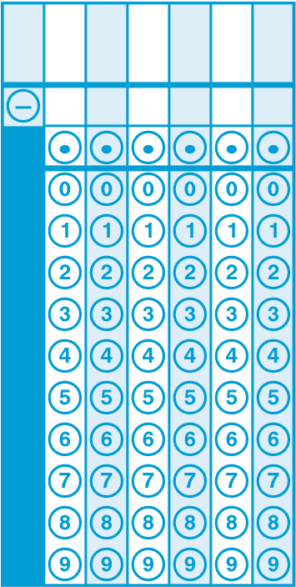

8.EE.A.4
Perform operations with numbers expressed in scientific notation, including problems where both decimal and scientific notation are used. Use scientific notation and choose units of appropriate size for measurements of very large or very small quantities (e.g., use millimeters per year for seafloor spreading). Interpret scientific notation that has been generated by technology. (Conceptual Understanding & Procedural Skill and Fluency & Application)

What test questions look like:
Sample 1:
The erosion rate along a section of the coast is approximately 3 feet per year. Which of these best approximates this rate of erosion?
    - 9.9 × 10^{–2} inches per day
    - 9.9 × 10^{–2} inches per month
    - 9.9 × 10^{–2} feet per day
    - 9.9 × 10^{–2} feet per month

8.EE.B.5

Graph proportional relationships, interpreting the unit rate as the slope of the graph. Compare two different proportional relationships represented in different ways. For example, compare a distance-time graph to a distance-time equation to determine which of two moving objects has greater speed. (Conceptual Understanding & Procedural Skill and Fluency & Application)
What test questions look like:

Sample 1:
Glenn and Martha run track for their school. Glenn can run lap in 1 minute. The graph below shows the number of laps Martha can run over time.
Martha’s Running
Time (minutes)
Number of Laps Run
0
14
12
10
8
6
4
2
2
4
6
8
10
12
14
y
x
Glenn and Martha decide to run a 20-lap race. If Glenn’s and Martha’s running rates remain constant for all 20 laps, which pair of statements about the race is correct?
  - Martha will win the race. She runs at a pace that is lap per minute faster than
Glenn.
  - Martha will win the race. She runs at a pace that is 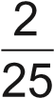 lap per minute faster than
Glenn.
  - Glenn will win the race. He runs at a pace that is lap per minute faster than
Martha.
  - Glenn will win the race. He runs at a pace that is 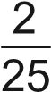 lap per minute faster than Martha.

Sample 2:
Two utility companies sell electricity in units of kilowatt-hours. The cost of electricity for company P is shown in the table. The cost of electricity for company M can be found by using the equation shown, where y represents the total cost in dollars for x kilowatt-hours of electricity.
Electricity Costs
Company P Company M
Number of Kilowatt-hours | Total Cost (dollars) | y = 0.15x
1,250 | 150.00
1,650 | 198.00

    - Use the information provided to find the unit rate, in dollars per kilowatt-hour, for each company. Show your work or explain your answers.
    - Find the total cost, in dollars, of buying 2,375 kilowatt-hours of electricity from the least expensive company.
Enter your answers and your work or explanation in the box provided.

8.EE.B.6
Use similar triangles to explain why the slope m is the same between any two distinct points on a non-vertical line in the coordinate plane; derive the equation y = mx for a line through the origin and the equation y = mx + b for a line intercepting the vertical axis at b. (Conceptual Understanding)

What test questions look like:
Sample 1:
Line m and triangle PQR are shown on the graph below.
6
5
4
3
2
1

–
1
–
2
–
3
–
4
–
5
–
6
3
6
5
4
2
1
–
5
–
4
–
3
–
2
–
1
y
–
6
x
P
Q
R
m
J
Greg is creating triangle JKL to be similar to triangle PQR. Each side of triangle JKL is parallel to one side of triangle PQR.
Select all the points that could be the location of point L.
  - (–2, –0)
  - (–1, –1.5)
  - (0, 0)
  - (2, 3)
  - (2.5, 3.5)
  - (5.5, 8)
8.EE.C.7
Solve linear equations in one variable. (Procedural Skill and Fluency)

What test questions look like:
Sample 1:
What is the value of x in this equation?
6x – 2x = 24

- 3
- 4
- 6
- 12

Sample 2:
Solve the following equation:
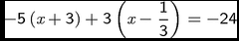.

- x = -4
- x = 4
- x = 5
- x = 20

8.EE.C.7a
Give examples of linear equations in one variable with one solution, infinitely many solutions, or no solutions. Show which of these possibilities is the case by successively transforming the given equation into simpler forms, until an equivalent equation of the form x = a, a = a, or a = b results (where a and b are different numbers). (Conceptual Understanding & Procedural Skill and Fluency)

What test questions look like:
Sample 1:
Consider the equation 2(x + 2) = 2 + 2x. How many solutions does this equation have?
    - 0 solutions
    - 1 solution
    - 2 solutions
    - infinitely many solutions

8.EE.C.7b
Solve linear equations with rational number coefficients, including equations whose solutions require expanding expressions using the distributive property and collecting like terms. (Procedural Skill and Fluency)

What test questions look like:
Sample 1:
Solve for x.
124.50 = 20(x + 4) + x + 3

    - 1.2
    - 1.5
    - 2
    - 10

Sample 2:
Determine whether the equation has no solution, one solution, or infinitely many solutions.
-2(11-12x) = -4(1-6x)
Show each step of your work. Explain your conclusion.
Enter your answer, your work, and your explanation in the box provided.
8.EE.C.8
Analyze and solve pairs of simultaneous linear equations. (Conceptual Understanding & Procedural Skill and Fluency)

What test questions look like:
Sample 1:
Two lines are graphed on the same coordinate plane. The lines intersect at the point (71/3 , 18) . Which system of equations could represent the two lines?

- 2x – 8 = 3y
x – 23 = 3y

- –4x + 110 = 6y
3x + 175 = 21y

- x + 33 = 9y
2x – 4 = 3y

- 6x + 10 = 3y
9x + 6 = 4y

Sample 2:
In one week, Jenny worked a total of 22 hours at a movie theater and a car wash.
Jenny earned $8.50 per hour at the movie theater and $8.00 per hour at the car wash. She earned a total of $181 for the week.
How many hours did Jenny work at the car wash?

- 8
- 10
- 11
- 12

8.EE.C.8a
Understand that solutions to a system of two linear equations in two variables correspond to points of intersection of their graphs, because points of intersection satisfy both equations simultaneously. (Conceptual Understanding)

What test questions look like:
Sample 1:
The graph of a system of two linear equations is shown.
x
y
–
1
–
1
–
2
–
3
–
4
–
5
5
4
3
2
1
–
2
–
3
–
4
–
1
2
3
4
5
5
How many solutions does the system of equations have?
  - 0 solutions
  - 1 solution
  - 3 solutions
  - infinitely many solutions

8.EE.C.8b
Solve systems of two linear equations in two variables algebraically, and estimate solutions by graphing the equations. Solve simple cases by inspection. For example, 3x + 2y = 5 and 3x + 2y = 6 have no solution because 3x + 2y cannot simultaneously be 5 and 6. (Conceptual Understanding & Procedural Skill and Fluency)

What test questions look like:
Sample 1:
What is the solution of the system of equations shown below?
-2x + 3y = 15
2x + 3y = 15
    - (2, 3)
    - (0, 5)
    - (7.5, 10)
    - (3.75, 2.5)

8.EE.C.8c
Solve real-world and mathematical problems leading to two linear equations in two variables. For example, given coordinates for two pairs of points, determine whether the line through the first pair of points intersects the line through the second pair. (Procedural Skill and Fluency & Application)

What test questions look like:
Sample 1:
Two membership levels are offered at a local bookstore.

Bookstore Memberships
Membership Level | Entry Fee | Cost per Book
silver | $40 | $19.25
gold | $69.25 | $16
How many books would need to be purchased from each membership so that the two membership levels cost the same amount?
Enter your answer in the box.
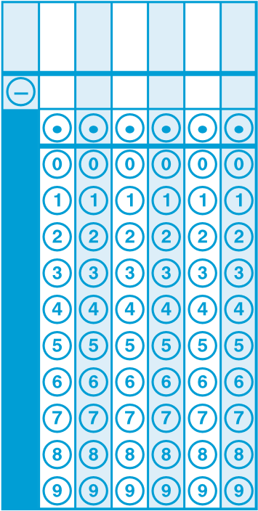

Sample 2:
A tutor schedules either 30-minute sessions or 60-minute sessions with her students. Last week, the tutor gave 8 sessions which lasted for a total of 7 hours. How many 60-minute sessions did the tutor give last week?
Enter your answer in the box.
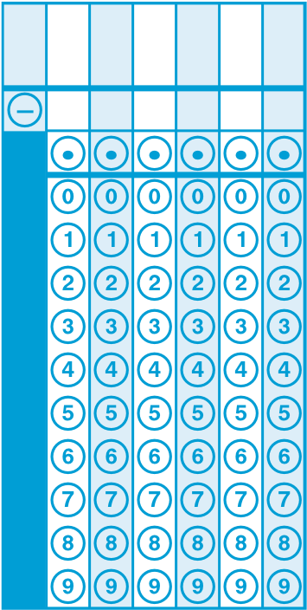
8.F.A.1
Understand that a function is a rule that assigns to each input exactly one output. The graph of a function is the set of ordered pairs consisting of an input and the corresponding output. (Conceptual Understanding)

What test questions look like:
Sample 1:
The table below shows the prices for different brands and different numbers of tires at Bill’s Tire Shop.

Bill’s Tire Shop
Brand | Number of Tires | Price ($)
Brand A | 1 | 120
Brand A | 4 | 450
Brand B | 1 | 140
Brand B | 4 | 450
Bill graphs the number of tires sold, x, and the price, y. Which statement explains why Bill’s graph is not a function?
- Each input has only one output.
- Each output has only one input.
- One input has more than one output.
- One output has more than one input

Sample 2:
Jason plots three points on a coordinate plane and sees that they do not create a function. The three points he plots are (–2, 5), (–5, 9), and (x, –3). What is a possible value of x that makes Jason’s three points not represent a function?
Enter your answer in the box.
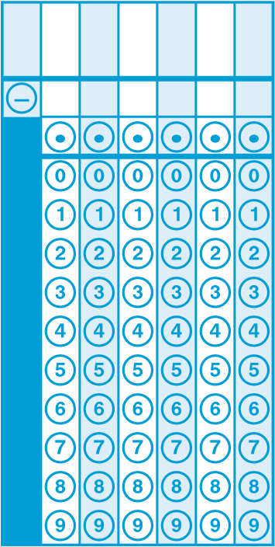

Sample 3:
Several points of a function are plotted on the coordinate plane below.
10
9
8
7
6
5
4
3
2
1
1
0
23
45
678
910
y
x
Select all the points that could be added to the graph so that it still represents a function.
    - (0, 3)
    - (2, 5)
    - (4, 6)
    - (6, 4)
    - (10, 10)

8.F.A.2
Compare properties of two functions each represented in a different way (algebraically, graphically, numerically in tables, or by verbal descriptions). For example, given a linear function represented by a table of values and a linear function represented by an algebraic expression, determine which function has the greater rate of change. (Conceptual Understanding & Procedural Skill and Fluency)
What test questions look like:
Sample 1:
The graph and table show the amount of gasoline in gallons, x, and total cost in dollars, y, of gasoline at two gas stations.
Gas Station P
Amount of Gasoline (gallons)
Total Cost (dollars)
50
45
40
35
30
25
20
15
10
5
1
0
2345678910
x
Gas Station M
x | y
5 | 19.00
10 | 38.00
15 | 57.00
Use the unit price of gasoline at both gas stations to determine which gas station charges more for gasoline (gallons). Be sure to include the unit prices in your answer. Show or explain your work.
Enter your answer and your work or explanation in the box provided.
Sample 2:
Diane and Rick are each swimming a 150-meter race. Each swims at a constant rate throughout the whole race. The graph and table below show the distances Diane and Rick have each traveled after different numbers of seconds.
Diane’s Swim Rick’s Swim
Time (seconds) | Distance Traveled (meters)
10 | 12.5
15 | 18.75
20 | 25
Time (seconds)
Distance Traveled (meters)
30
25
20
15
10
5
0
10
15
20
25
5
x

Based on the rates in the graph and the table, what is the difference, in seconds, between Diane’s total race time and Rick’s total race time?
Enter your answer in the box.
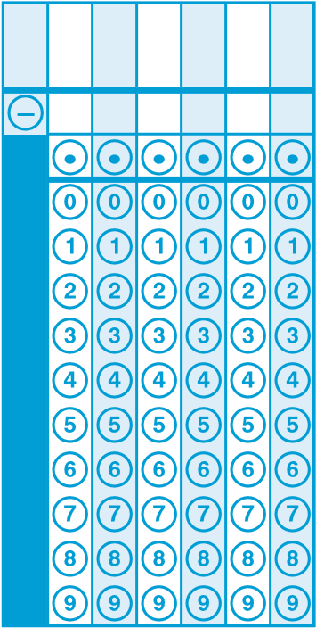

8.F.A.3
Interpret the equation y = mx + b as defining a linear function, whose graph is a straight line; give examples of functions that are not linear. For example, the function A = s²giving the area of a square as a function of its side length is not linear because its graph contains the points (1, 1), (2, 4) and (3, 9), which are not on a straight line. (Conceptual Understanding)

What test questions look like:
Sample 1:
Select all the equations that represent y as a linear function of x.
  - x = 2
  - x = 2y
  - x = y²
  - y = 2
  - y = 2x
  - y = x²
8.F.B.4
Construct a function to model a linear relationship between two quantities. Determine the rate of change and initial value of the function from a description of a relationship or from two (x, y) values, including reading these from a table or from a graph. Interpret the rate of change and initial value of a linear function in terms of the situation it models, and in terms of its graph or a table of values. (Conceptual Understanding & Procedural Skill and Fluency & Application)

What test questions look like:
Sample 1:
A tank of water was drained at a constant rate. The table shows the number of gallons of water left in the tank after being drained for two amounts of time.
Draining Time (minutes) | Water in Tank (gallons)
10 | 450
30 | 330

Part A
What is the rate at which the water was drained from the tank?
- 6 gallons of water per minute
- 11 gallons of water per minute
- 45 gallons of water per minute
- 120 gallons of water per minute

Part B
What was the total amount of water in the tank before it was drained?
- 450 gallons
- 510 gallons
- 560 gallons
- 570 gallons

8.F.B.5
Describe qualitatively the functional relationship between two quantities by analyzing a graph (e.g., where the function is increasing or decreasing, linear or nonlinear). Sketch a graph that exhibits the qualitative features of a function that has been described verbally. (Conceptual Understanding & Application)
What test questions look like:
Sample 1:
The graph below shows the function relating two quantities, x and y.
10
9
8
7
6
5
4
3
2
1

–
1
–
2
–
3
–
4
–
5
–
6
–
7
–
8
–
9
–
10
6
7
8
910
5
1
2
3
4
–
10
–
9
–
8
–
7
–
6
–
5
–
4
–
3
–
2
–
1
y
x
Which description of the function is correct?
- The function is linear.
- The function is nonlinear.
- The function is linear for x < 0 and nonlinear for x > 0.
- The function is nonlinear for x < 0 and linear for x > 0.
8.G.A.1
Verify experimentally the properties of rotations, reflections, and translations: (Conceptual Understanding)

What test questions look like:
Sample 1:
Abraham draws a pattern. He starts his pattern by drawing Figure 1 as shown below.
Abraham’s Pattern
10
9
8
7
6
5
4
3
2
1
1
23
45
678
910
0
y
x
Figure 1
He then rotates the figure 180° around the point (2, 3), translates the figure 4 units to the right, and labels it Figure 2.
Which statement about the two figures must be true?
Select all that apply.
- Each figure has one pair of parallel line segments.
- The two figures have at least one point in common.
- The area of Figure 1 is less than the area of Figure 2.
- The figures lie in different quadrants of the coordinate plane.
- The acute angles in each figure are congruent to one another.
- The perimeter of Figure 1 is greater than the perimeter of Figure 2.

8.G.A.1a
Lines are taken to lines, and line segments to line segments of the same length. (Conceptual Understanding)

What test questions look like:
Sample 1:
If a horizontal line is rotated 90˚ counterclockwise about the origin, what would be the resulting image?

A. The image line is 90 times as long.
- The image is a vertical line.
- The image is a line 90 units long.
- The image is a horizontal line.

8.G.A.1b
Angles are taken to angles of the same measure. (Conceptual Understanding)

What test questions look like:
Sample 1:

Use the picture to answer the question.
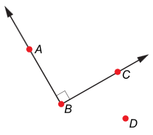
Angle ABC is rotated 50° around point D.
What is the measure of angle A'B'C'?

- 40°
- 50°
- 90°
- 130°

8.G.A.1c
Parallel lines are taken to parallel lines. (Conceptual Understanding)

What test questions look like:
Sample 1:
None Available

8.G.A.2
Understand that a two-dimensional figure is congruent to another if the second can be obtained from the first by a sequence of rotations, reflections, and translations; given two congruent figures, describe a sequence that exhibits the congruence between them. (Conceptual Understanding)

What test questions look like:
Sample 1:
A shape with an area of 14.5 square feet goes through the two transformations listed below.
    - rotate 90° clockwise around its center
    - translate 8 units to the right
What is the area, in square feet, of the shape after the two transformations?
  - 14.5
  - 22.5
  - 104.5
  - 116

Sample 2:
Use the information provided to answer Part A and Part B for question 31.
In the coordinate plane shown, triangle ABC is congruent to triangle A'B'C'.
Triangle A'B'C' is similar to triangle A"B"C".
7
6
5
4
3
2
1

–
1
–
2
–
3
–
4
–
5
–
6
–
7
5
3
2
1
4
6
7
–
5
–
4
–
3
–
2
–
1
y
–
6
–
7
x
A
B
C
A'
C'
B'
A''
C''
B''

Part A
Describe a single transformation that shows that triangle A'B'C' is congruent to triangle ABC. Include all the necessary information to complete the transformation.
Enter your description in the box provided.

Part B
Describe a sequence of transformations that shows that triangle A"B"C" is similar to triangle A'B'C'. Include all the necessary information to complete each transformation.
Enter your description in the box provided.

8.G.A.3
Describe the effect of dilations, translations, rotations, and reflections on two-dimensional figures using coordinates. (Conceptual Understanding & Procedural Skill and Fluency)

What test questions look like:
Sample 1:
Rachel draws the graphic shown below in a computer program. She labels the tip of the arrow P.
Rachel’s Graphic
10
9
8
7
6
5
4
3
2
1
1
0
23
45
678
910
y
x
P
She then uses the program to dilate the figure by a factor of 2. The dilation is centered at the origin. After the dilation, the tip of the arrow is labeled P'. Which ordered pair describes the location of P'?
    - (4, 10)
    - (6, 7)
    - (8, 10)
    - (12, 15)

8.G.A.4
Understand that a two-dimensional figure is similar to another if the second can be obtained from the first by a sequence of rotations, reflections, translations, and dilations; given two similar two-dimensional figures, describe a sequence that exhibits the similarity between them. (Conceptual Understanding)
What test questions look like:
Sample 1:
On the coordinate plane shown, Figure 1 is transformed into Figure 2, which is transformed into Figure 3. Figure 1 and Figure 3 are similar by a sequence of transformations.
12
10
8
6
4
2

–
2
–
4
–
6
–
8
–
10
–
12
6
4
10
12
8
2
–
10
–
8
–
6
–
4
–
2
y
–
12
x
1
2
3

Part A
What type of transformation was used to transform Figure 1 into Figure 2?
- dilation
- reflection
- rotation
- translation

Part B
Which statement describes the transformation of Figure 2 into Figure 3?
- reflection across the x-axis
- reflection across the y-axis
- translation 4 units to the right
- translation 6 units to the right

Sample 2:
Erin designs packaging for a company. She draws a two-dimensional figure to represent the base of a small package. To represent the base of a large package, she performs the following steps on the original figure:
      - First, she dilates it by a factor greater than 1, centered at the origin.
      - Then, she rotates it.
      - Finally, she dilates it by a factor less than 1, centered at the origin.
Which statement best describes the figure representing the base of the large package?
    - It must be both similar and congruent to the figure representing the base of the small package.
    - It must be similar and could be congruent to the figure representing the base of the small package.
    - It could be similar and must be congruent to the figure representing the base of the small package.
    - It cannot be similar or congruent to the figure representing the base of the small package.

8.G.A.5
Use informal arguments to establish facts about the angle sum and exterior angle of triangles, about the angles created when parallel lines are cut by a transversal, and the angle-angle criterion for similarity of triangles. For example, arrange three copies of the same triangle so that the sum of the three angles appears to form a line, and give an argument in terms of transversals why this is so. (Conceptual Understanding)

What test questions look like:
Sample 1:
In the figure shown, is parallel to .
J
K
M
L
N

Part A
When comparing ΔKJN and ΔLJM, Tara states that KJN and LJM are congruent. Explain why Tara’s statement is correct.
Enter your explanation in the box provided.

Part B
Tara wants to prove that a second pair of corresponding angles from ΔKJN and ΔLJM are congruent. Determine a second pair of corresponding angles from ΔKJN and ΔLJM that are congruent. Then explain how you know that the two angles are congruent.
Enter your explanation in the box provided.

8.G.B.6
Explain a proof of the Pythagorean Theorem and its converse. (Conceptual Understanding)

What test questions look like:
Sample 1:
Shaun is proving the Pythagorean Theorem. He has drawn the figure shown below as part of his proof.
b
c
c
c
c
a
b
a
b
a
a
b
He wants to show that the area of the large square is equal to the sum of the areas of the small triangles and the small square. Which equation should Shaun write to represent this equality?
  - 2ab + c² = (a + b)²
  - 2ab + c² = a² + b²
  - 4ab + c² = (a + b)²
  - 4ab + c² = a² + b²

8.G.B.7
Apply the Pythagorean Theorem to determine unknown side lengths in right triangles in real-world and mathematical problems in two and three dimensions. (Procedural Skill and Fluency & Application)

What test questions look like:
Sample 1:
In ΔABC, is perpendicular to . The dimensions are shown in centimeters.
B
D
8
C
10
10
A
What is the length, in centimeters, of ?
Enter your answer in the box.
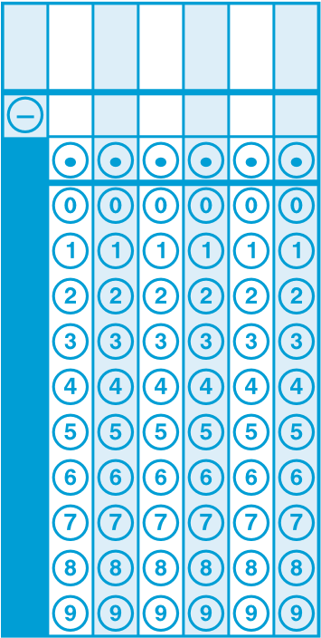

Sample 2:
Evan is making a podium in the shape of a rectangular prism. He puts a diagonal brace from the upper back corner to the lower front corner of the podium, as represented by the dashed line in the figure below.
2
feet
2
feet
4
feet
Evan’s Podium
What is the approximate length of the diagonal brace, rounded to the nearest tenth of a foot?
  - 2.4
  - 2.8
  - 4.5
  - 4.9

8.G.B.8
Compute unit rates associated with ratios of fractions, including ratios of lengths, areas and other quantities measured in like or different units. For example, if a person walks 1/2 mile in each 1/4 hour, compute the unit rate as the complex fraction ^{1/2}/_{1/4} miles per hour, equivalently 2 miles per hour. (Procedural Skill and Fluency)

What test questions look like:
Sample 1:
Rectangle ABCD is shown.
x
y
–
1
–
1
–
2
–
3
–
4
–
5
5
4
3
2
1
–
2
–
3
–
4
–
1
2
3
4
5
5
A
B
C
D
What is the length of side AB?

- $\sqrt{4}$ Units
- $4$ units
- $\sqrt{32}$ units
- 32 units

8.G.C.9
Know the formulas for the volumes of cones, cylinders, and spheres and use them to solve real-world and mathematical problems. (Conceptual Understanding & Procedural Skill and Fluency & Application)
What test questions look like:
Sample 1:
Consider the figures shown to answer Part A and Part B for question 40.
Cone #2
Cone #1
Cylinder #1
Cylinder #2
Sphere
in.
15
in.
6
in.
6
in.
15
6
in.
in.
6
5
in.
5
in.
in.
6

Part A
Which figures have a volume greater than 600 cubic inches?
Select all that apply.

- Cylinder #1
- Cone #1
- Cylinder #2
- Cone #2
- Sphere

Part B

How many times greater is the volume of the Sphere than the volume of Cone #1? Round your answer to the nearest tenth.
Enter your answer in the box.
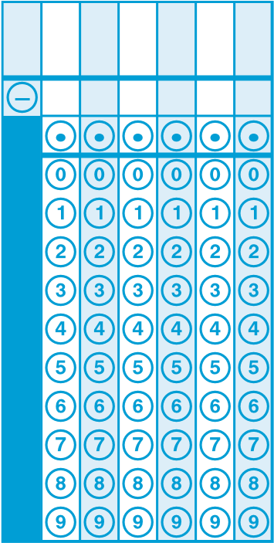
8.SP.A.1
Construct and interpret scatter plots for bivariate measurement data to investigate patterns of association between two quantities. Describe patterns such as clustering, outliers, positive or negative association, linear association, and nonlinear association. (Conceptual Understanding & Application)

What test questions look like:
Sample 1:
Use the table below to answer this question.
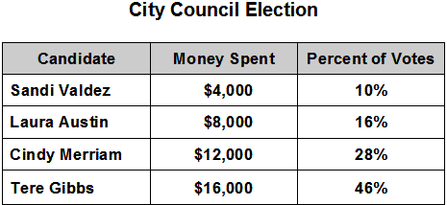
This table shows the amount of money 4 candidates for City Council each spent on their campaigns, and the percent of votes each candidate received. Which of these statements best describes the data in the table?

- There is a positive linear relationship between money spent and votes received.

- There is a positive non-linear relationship between money spent and votes received.

- There is a negative linear relationship between money spent and votes received.

- There is a negative non-linear relationship between money spent and votes received.

Sample 2:
A baseball coach places baseballs in a cart. He uses the baseballs to pitch to the players during practice. The numbers of baseballs remaining in the cart after different practice lengths, in minutes, are displayed in the scatter plot below.
Which statement about the scatter plot is true?
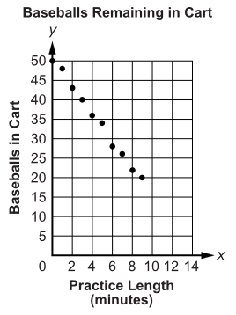
Select each correct statement.
- The scatter plot shows a positive association.
- The scatter plot shows a negative association.
- The scatter plot shows no association.
- As the length of practice time increases the number of baseballs in the cart decreases.
- As the number of baseballs in the cart increases the practice time decreases.
- As the number of baseballs in the cart increases the practice time increases.
- All the points are clustered around 34 baseballs in the cart.
- The point at 50 baseballs in the cart is an outlier.

8.SP.A.2
Know that straight lines are widely used to model relationships between two quantitative variables. For scatter plots that suggest a linear association, informally fit a straight line, and informally assess the model fit by judging the closeness of the data points to the line. (Conceptual Understanding)
What test questions look like:
Sample 1:
- A scatter plot is shown on the coordinate plane.
10
9
8
7
6
5
4
3
2
1
1
0
2 3 4 5 6 7 8 9 10
y
x
Which of these most closely approximates a line of best fit for the data in the scatter plot?
(Answers continued on next page.)
A y B y
10 10
9 9
8 8
7 7
6 6
5 5
4 4
3 3
2 2 1 1
0 1 2 3 4 5 6 7 8 9 10 0 1 2 3 4 5 6 7 8 9 10

C y D y
10 10
9 9
8 8
7 7
6 6
5 5
4 4
3 3
2 2 1 1

8.SP.A.3
Use the equation of a linear model to solve problems in the context of bivariate measurement data, interpreting the slope and intercept. For example, in a linear model for a biology experiment, interpret a slope of 1.5 cm/hr as meaning that an additional hour of sunlight each day is associated with an additional 1.5 cm in mature plant height. (Conceptual Understanding & Application)
What test questions look like:
Sample 1:
Eric planted a seedling in his garden and recorded its height each week. The equation shown can be used to estimate the height, h, in inches, of the seedling by the end of each week, w, after it was planted.
H = w +

Part A

What does the slope of the graph of the equation h = w + represent?
- the height, in inches, of the seedling after w weeks
- the height, in inches, of the seedling when Eric first planted it
- the increase in the height, in inches, of the seedling each week
- the total increase in the height, in inches, of the seedling after w weeks

Part B
The equation h = w + estimates the height of the seedling to be 8.25 inches after how many weeks?
Enter your answer in the box.
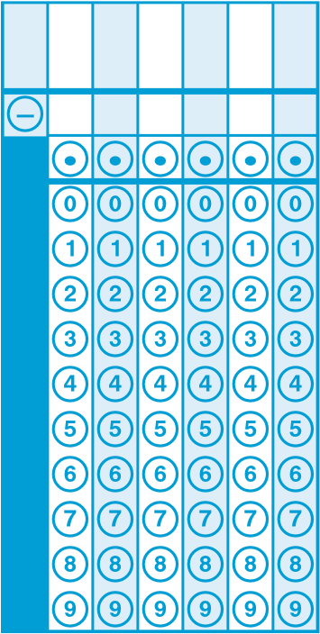

8.SP.A.4
Understand that patterns of association can also be seen in bivariate categorical data by displaying frequencies and relative frequencies in a two-way table. Construct and interpret a two-way table summarizing data on two categorical variables collected from the same subjects. Use relative frequencies calculated for rows or columns to describe possible association between the two variables. For example, collect data from students in your class on whether or not they have a curfew on school nights and whether or not they have assigned chores at home. Is there evidence that those who have a curfew also tend to have chores? (Conceptual Understanding & Procedural Skill and Fluency & Application)

What test questions look like:
Sample 1:
The table shows the results of a random survey of students in grade 7 and grade 8. Every student surveyed gave a response. Each student was asked if he or she exercised less than 5 hours last week or 5 or more hours last week.
 | Less than 5 Hours | 5 or More Hours
Grade 7 Students | 49 | 63
Grade 8 Students | 58 | 51
Based on the results of the survey, which statements are true?
Select each correct statement.
  - More grade 8 students were surveyed than grade 7 students.
  - A total of 221 students were surveyed.
  - Less than 50% of the grade 8 students surveyed exercised 5 or more hours last week.
  - More than 50% of the students surveyed exercised less than 5 hours last week.
  - A total of 107 grade 7 students were surveyed.

Sample 2:
A survey of 7th and 8th grade students asked whether they were in favor of or against school uniforms. The two-way table shows the results.
Survey Results
Grade | Number of Students
 | In Favor | Against | Total
7th | 48 | 64 | 112
8th | 68 | 70 | 138
Total | 116 | 134 | 250

To the nearest tenth of a percent, what percent of the 7th grade students were in favor of wearing school uniforms?
- 19.2%
- 41.3%
- 42.9%
- 57.1%

8th Grade
Sample Math Items Aligned to CCSS
Key
CCSS Code | Sample 1 | Sample 2 | Sample 3 | Sample 4
8.NS.A.1 | D
8.NS.A.2 | B | B
8.EE.A.1 | C, D, F
8.EE.A.2 | B
8.EE.A.3 | 20
8.EE.A.4 | A
8.EE.B.5 | A | See Rubric #27
8.EE.B.6 | B, C, D
8.EE.C.7 | C | B
8.EE.C.7a | A
8.EE.C.7b | C | See Rubric #30
8.EE.C.8 | D | D
8.EE.C.8a | B
8.EE.C.8b | B
8.EE.C.8c | 9 | 6
8.F.A.1 | C | -2 OR -5 | A, C, E
8.F.A.2 | See Rubric #32 | 20
8.F.A.3 | B, D, E
8.F.B.4 | Part A: A  Part B: B
8.F.B.5 | B
8.G.A.1 | A, E
8.G.A.1a | B
8.G.A.1b | C
8.G.A.1c | None Available
8.G.A.2 | A | See Rubric #31
8.G.A.3 | C
8.G.A.4 | Part A: A  Part B: B | B
8.G.A.5 | See Rubric #37
8.G.B.6 | A
8.G.B.7 | 12 | D
CCSS Code | Sample 1 | Sample 2 | Sample 3 | Sample 4
8.G.B.8 | C
8.G.C.9 | Part A: C, E  Part B: 4.8
8.SP.A.1 | B | B, D
8.SP.A.2 | A
8.SP.A.3 | Part A: C  Part B: B
8.SP.A.4 | B, C | C

8.EE.B.5 Sample #2 (Rubric #27)
Score | Description
3 | Student response includes each of the following 3 elements:  - Finds unit rates for both companies  - Valid work or explanation of how unit rates are found for each company  - Finds the cost of buying 2,375 kilowatt-hours of electricity from the least expensive company  Sample Student Response:  The unit rate for Company P is $0.12 per kilowatt-hour of electricity. When I divide the cost by the number of kilowatt-hours of electricity I get the unit rate.  150.00 ÷ 1250 = 0.12  198.00 ÷ 1650 = 0.12  The slope of a linear function can be considered the function’s rate. The unit rate for Company M is $0.15 per kilowatt-hour of electricity.  It costs $285.00 to buy 2,375 kilowatt-hours of electricity from Company P.
2 | Student response includes 2 of the 3 elements.
1 | Student response includes 1 of the 3 elements.
0 | Student response is incorrect or irrelevant.

8.EE.C.7b Sample #2 (Rubric #30)
Score | Description
3 | Student response includes the following 3 elements. x Computation component = 1 point  o Correct conclusion about the equation with an appropriate explanation of why the conclusion is valid  x Reasoning component = 2 points  - Correctly uses the distributive property to simplify both sides of the equation  - Correctly combines like terms, resulting in a false equation in which the variable has been eliminated and two non-equal numbers appear on opposite sides of the equal sign  Sample Student Response:  -2(11-12x) = -4(1-6x)  -22+24x = -4 +24x  Subtracting 24x from each side -22+24x -24x = -4 +24x -24x  -22 = -4  This is impossible, since -22 is not equal to -4. Therefore, there is no solution to the equation.
2 | Student response includes 2 of the 3 elements.
1 | Student response includes 1 of the 3 elements.
0 | Student response is incorrect or irrelevant.

8.F.A.2 Sample #1 (Rubric #32)
Score | Description
3 | Student response includes the following 3 elements. x Computation component = 1 point  o Determines the unit price for both gas stations  x Modeling component = 2 points  o Determines that gas station P charges more for gasoline o Correctly models determining the unit prices and the gas station that charges more for gasoline.  Sample Student Response:  Based on the unit prices, Gas Station P charges more for gasoline. The unit price for Gas Station P is $4.00 per gallon since the constant linear graph for Gas Station P shows the point (5, 20), which means it costs $20 for 5 gallons of gas. The table for Gas Station M shows that 10 gallons cost $38, so the unit price for Gas Station M is ³⁸/₁₀ = $3.80 per gallon.
2 | Student response includes 2 of the 3 elements.
1 | Student response includes 1 of the 3 elements.
0 | Student response is incorrect or irrelevant.

8.G.A.2 Sample # 2 (Rubric #31)
Part A
Score | Description
2 | Student response includes each of the following 2 elements:  - Identifies the transformation as a reflection  - Identifies the reflection is across the line x = 1  Sample Student Response:  The transformation from ABC to A’B’C’ is a reflection across the line x = 1.  Note: The student can receive 1 point for part A if they describe a correct sequence of transformations instead of a single transformation.
1 | Student response includes 1 of the 2 elements.
0 | Student response is incorrect or irrelevant.
(Rubric #31)
Part B
2 | Student response includes each of the following 4 elements:  - Identifies the transformation as a reflection  - Identifies the reflection is across the x-axis  - Identifies the transformation as a dilation with scale factor of 2  - Identifies the center of dilation as point C’  Sample Student Response:  To show the triangles are similar, dilate triangle A’B’C’ using a scale factor of 2 with C’ as the center of dilation. Then reflect the triangle across the x-axis.
1 | Student response includes 2 or 3 of the 4 elements.
0 | Student response is incorrect or irrelevant.

8.G.A.5 Sample #1 (Rubric #37)
Part A
Score | Description
1 | Student response includes the following element.  - Reasoning component = 1 point  o Correctly reasons why ∠KJN and ∠LJM are both congruent  Sample Student Response:  ∠KJN is congruent to ∠LJM because they are the same angle since they exactly overlap.
0 | Student response is incorrect or irrelevant.
(Rubric #37)
Part B
Score | Description
2 | Student response includes the following element.  - Reasoning component = 2 points  - correct pair of corresponding congruent angles, ∠JKN and  ∠JLM or ∠JNK and ∠JML  - correctly reasons why the given pair of angles is congruent  Sample Student Response:  ∠JKN is congruent to ∠ JLM  OR  ∠JNK is congruent to ∠JML  Either line segment JL or line segment JM is a transversal to the parallel line segments KN and LM. When two parallel lines are intersected by a transversal, corresponding angles formed by the transversal are congruent. The pair of angles is also corresponding in terms of their locations in $∆$KJN and $∆$LJM.
1 | Student response includes 1 of the 2 elements.
0 | Student response is incorrect or irrelevant.

8th Grade
Sample Math Items Aligned to CCSS
Origination of Sample Items
CCSS Code | Sample 1 | Sample 2 | Sample 3 | Sample 4
8.NS.A.1 | 2016 Leap Practice Test #2
8.NS.A.2 | 2016 Leap Practice Test #8 | 2016 Leap Practice Test #15
8.EE.A.1 | 2016 Leap Practice Test #17
8.EE.A.2 | 2016 Leap Practice Test #1
8.EE.A.3 | 2016 Leap Practice Test #10
8.EE.A.4 | 2016 Leap Practice Test #20
8.EE.B.5 | 2016 Leap Practice Test #22 | 2016 Leap Practice Test #27
8.EE.B.6 | 2016 Leap Practice Test #33
8.EE.C.7 | Eagle | Eagle
8.EE.C.7a | 2016 Leap Practice Test #13
8.EE.C.7b | 2016 Leap Practice Test #16
8.EE.C.8 | Eagle | Eagle
8.EE.C.8a | 2016 Leap Practice Test #25
8.EE.C.8b | 2016 Leap Practice Test #11
8.EE.C.8c | 2016 Leap Practice Test #28 | 2016 Leap Practice Test #39
8.F.A.1 | 2016 Leap Practice Test #4 | 2016 Leap Practice Test #18 | 2016 Leap Practice Test #19
8.F.A.2 | 2016 Leap Practice Test #32 | 2016 Leap Practice Test #36
8.F.A.3 | 2016 Leap Practice Test #5
8.F.B.4 | 2016 Leap Practice Test #23
8.F.B.5 | 2016 Leap Practice Test #43
8.G.A.1 | 2016 Leap Practice Test #6
8.G.A.1a | Eagle
8.G.A.1b | Eagle
8.G.A.1c | None Available
CCSS Code | Sample 1 | Sample 2 | Sample 3 | Sample 4
8.G.A.2 | 2016 Leap Practice Test #3 | 2016 Leap Practice Test #31
8.G.A.3 | 2016 Leap Practice Test #12
8.G.A.4 | 2016 Leap Practice Test #7 | 2016 Leap Practice Test #14
8.G.A.5 | 2016 Leap Practice Test #37
8.G.B.6 | 2016 Leap Practice Test #35
8.G.B.7 | 2016 Leap Practice Test #21 | 2016 Leap Practice Test #38
8.G.B.8 | 2016 Leap Practice Test #24
8.G.C.9 | 2016 Leap Practice Test #40
8.SP.A.1 | Eagle | Eagle
8.SP.A.2 | 2016 Leap Practice Test #9
8.SP.A.3 | 2016 Leap Practice Test #29
8.SP.A.4 | 2016 Leap Practice Test #26 | 2016 Leap Practice Test #34

